2.87: Take +y to be downward.
Last 1.0 s of fall:
v_{0y} is his speed at the start of this time interval.
Motion from roof to 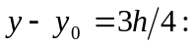
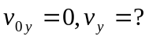
This is v_{y} for the last 1.0 s of fall. Using this in the equation for the first 1.0 s gives
